**Project Design Phase-II**

**Data Flow Diagram & User Stories**

|  |  |
| --- | --- |
| Date | **27 June 2025** |
| Team ID | **LTVIP2025TMID60609** |
| Project Name | **DocSpot: Seamless Appointment Booking for Health.** |
| Maximum Marks | 4 Marks |

**Data Flow Diagrams:**

A Data Flow Diagram (DFD) is a traditional visual representation of the information flows within a system. A neat and clear DFD can depict the right amount of the system requirement graphically. It shows how data enters and leaves the system, what changes the information, and where data is stored.

**Example:** [**(Simplified)**](https://developer.ibm.com/patterns/visualize-unstructured-text/)

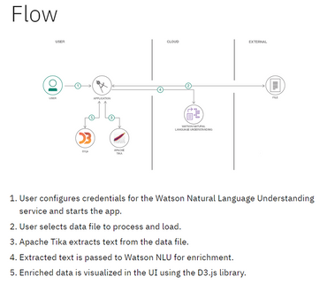

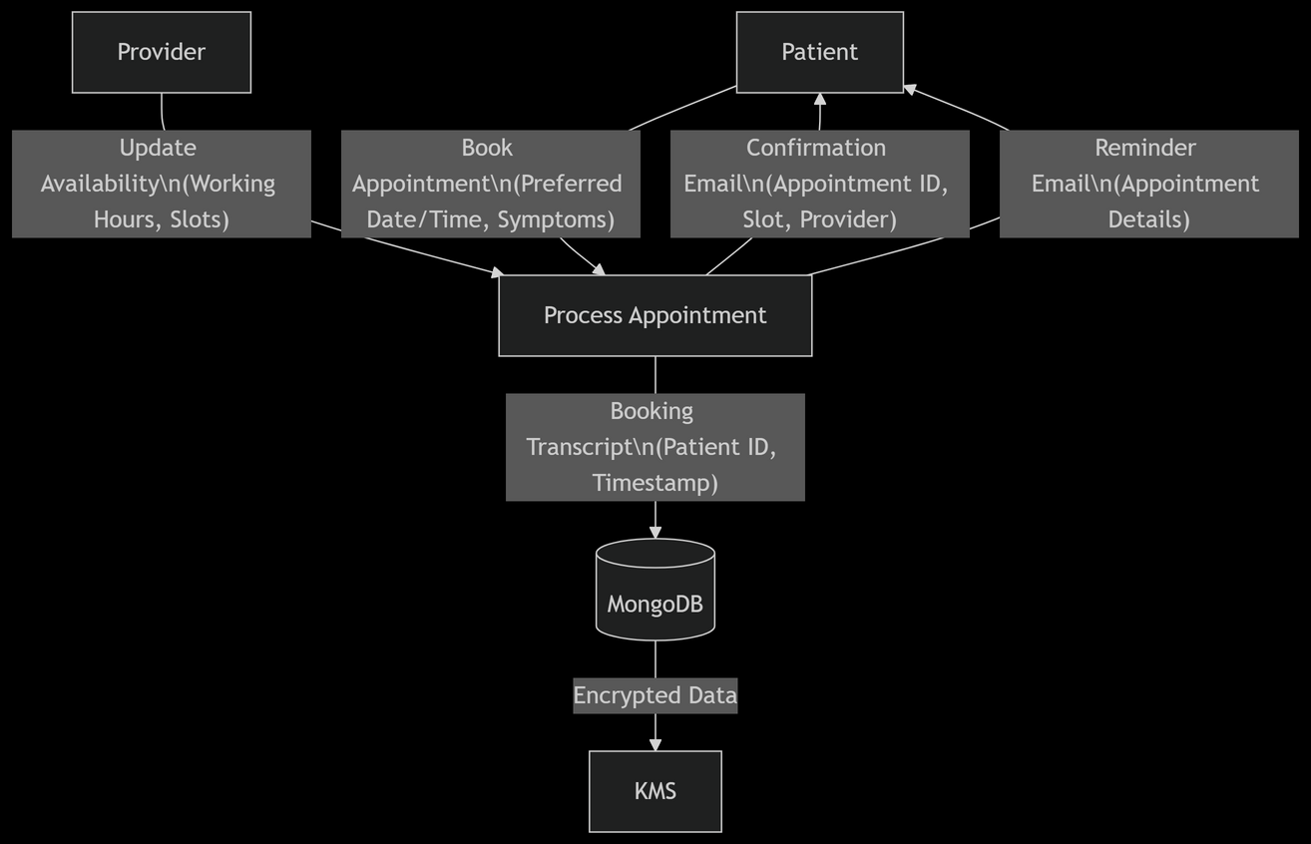

**User Stories**

Use the below template to list all the user stories for the product.

|  |  |  |  |  |  |  |
| --- | --- | --- | --- | --- | --- | --- |
| **User Type** | **Functional Requirement (Epic)** | **User Story Number** | **User Story / Task** | **Acceptance Criteria** | **Priority** | **Release** |
| Customer (Mobile user) | Registration | USN-1 | As a user, I can register for the application by entering my email, password, and confirming my password. | I can access my account / dashboard | High | Sprint-1 |
| Customer (Mobile user) | Registration | USN-2 | As a user, I will receive a confirmation email once I have registered for the application. | I can receive confirmation email & click confirm | High | Sprint-1 |
| Customer (Mobile user) | Registration | USN-3 | As a user, I can register for the application through Facebook. | I can register & access the dashboard with Facebook login | Low | Sprint-2 |
| Customer (Mobile user) | Registration | USN-4 | As a user, I can register for the application through Gmail. | I can register and log in using my Gmail account | Medium | Sprint-1 |
| Customer (Mobile user) | Login | USN-5 | As a user, I can log into the application by entering email & password. | I can successfully access my dashboard after login | High | Sprint-1 |
| Customer (Mobile user) | Dashboard | USN-6 | As a user, I can view available doctors by location and specialty. | I can see filtered doctor listings | High | Sprint-1 |
| Customer (Mobile user) | Booking | USN-7 | As a user, I can book appointments with available doctors. | I can select a doctor, time, and confirm booking | High | Sprint-1 |
| Customer (Mobile user) | Notification | USN-8 | As a user, I receive a confirmation SMS/email after booking. | I receive booking notification instantly | Medium | Sprint-2 |
| Customer (Mobile user) | Teleconsultation | USN-9 | As a user, I can attend a video consultation with the doctor. | I can join the call from the dashboard at appointment time | High | Sprint-2 |